Child Development Scientific Meme Project
Requirements and Instructions

Purpose of the Project

The purpose of this project is to help you apply child development concepts and improve your critical thinking skills. This will be accomplished by having you create scientific memes that will be shared with your classmates and on social media.

Ahhh, memes. Whether you like or dislike them, they are a big part of our online and social media culture. Memes show up regularly on our social media feeds. Even though the messages in memes are sometimes funny, impactful, and capture our attention, they may be totally devoid of scientific accuracy. But it doesn’t have to be that way.

The memes you create for this project will be used to publicly disseminate scientifically accurate information about child development. While your memes may be humorous and entertaining, they should also provide scientifically accurate information.

Please note: the assignment is built around memes, but I am very open to having you do another method for sharing information about child development with the public. For examples, Tik Toks, Reels, short audio descriptions (mini podcasts), and other ideas are welcome. Just pitch your idea to me!

Project Requirements

Step 1: Creating Scientific Meme Drafts
Due by 11:59 PM CT on Friday, September 9

- Create 3 memes based on child development myths or misconceptions. These are commonly-held misunderstandings about developmental psychological topics. Each meme should represent a different child development myth or misconception. Your job with each meme is to highlight and correct the myth or misconception. Your meme should communicate the accurate information to the general public who may be misled by the claim.

- Your sources for the memes will be short critical thinking articles pertaining to commonly-held myths or misconceptions related to child development. Each meme should focus on ONE article—in other words, select three articles from the list and create one meme for EACH article. I have supplied copies of these articles and the list of articles from which you can choose on Blackboard (See: Meme Project Requirements folder). Please only use these articles as the sources for your memes.

  - Note: There are only 25 articles from which you can choose for your memes, so you may end up picking the same article (or articles) as someone else in the class—this is okay and expected.

- To create your memes, go to a free online meme generator like MemeGenerator (https://imgflip.com/memegenerator), Quickmeme (http://www.quickmeme.com/), or Make a Meme (https://makeameme.org/). When creating your memes, be sure to select an image that is appropriate and relevant to your meme topic and include a brief and accurate meme message.

- To share your memes for peer review, post your 3 memes to Perusall for peer review as three separate Perusall assignments. Upload them as documents. It works best to paste the image in a word document and accompany it with the text described in the bullet below:

- For each of your meme rough draft submissions, please also include 1-2 written paragraphs that include the following:

(a) The title of the myth or misconception article on which your meme is based.

(b) An explanation of the myth or misconception in more detail (based on content from the myth or misconception article).

(c) A statement telling us why this meme matters (i.e., Why or how is it important to you and/or the general public?).

Refer to the end of this handout for examples of memes and written paragraphs from a prior course. You can also see examples on Dr. Clinton-Lisell’s twitter account @drclintonlisell

Each of your meme rough drafts are worth 10 points each. If you follow the guidelines, you will receive full credit.

Step 2: Peer Reviewing Meme Drafts
Due by 11:59 PM on Friday, September 16

Browse the memes posted by your classmates on the Meme Project Rough Draft Perusal Assignments. Post a reply on at least 6 memes other than your own (or 2 memes per Perusall assignment). You may comment to more than one meme created by the same student, but please post replies to as many different students as you can. Feedback should include any general comments about the meme, suggestions for improvement, and a statement about whether the meme appears to be appropriate to post on social media. You have a minimum of one comment on what was specifically done well with the meme and one specific suggestion for improvement. You will receive five points for each meme you provide feedback for a maximum of 30 points (five points for six memes).

Step 3: Submitting Final Copies of Memes
Due by 11:59 PM on Friday, September 30th

Based on peer feedback, make any of the necessary changes to your memes before submitting the final copies of all 3 memes for Dr. Clinton-Lisell to grade. Final copy submissions can be made using the assignment link inside the Meme Project Requirements folder.

Step 4. Posting Memes on Social Media

After your memes have been approved by your peers and Dr. Clinton-Lisell, one of the memes will be chosen and posted on Dr. Clinton-Lisell public Twitter profile (by Dr. Clinton-Lisell). You are welcome and encouraged to follow the account (@drclintonlisell) to track any responses to the meme project tweets! You are also encouraged to post on your own social media accounts (the whole purpose of this is to effectively communicate about scientific knowledge in child development). If you do not want your meme posted, please let Dr. Clinton-Lisell know by commenting on this with your final draft submission.

Your final memes will be graded based on the following (25 points each; total of 75 points):
Paragraph explains myth and why it’s wrong___/10
Meme accurately depicts myth debunked__/10
Explanation of why the meme matters __/5

Example 1: Scientific Meme and Written Paragraph (although not specifically this assignment)

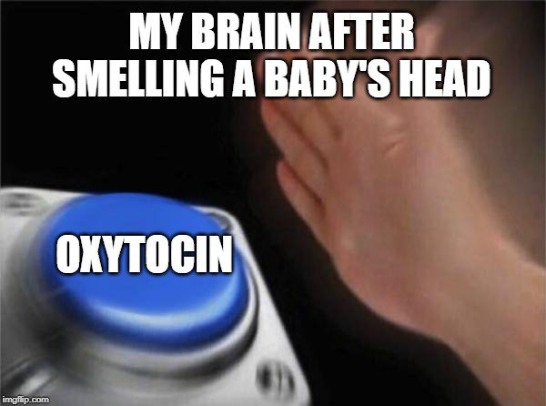

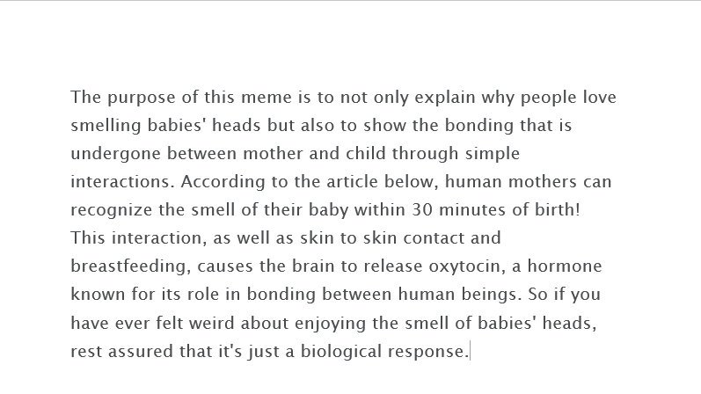

Example 2: Meme and Written Paragraph Scientific Meme and Written Paragraph (although not specifically this assignment)

